Grade 3: Cluster 6
Applying the Operations to Area and Perimeter
Family Letter

Dear ____________

During the week of <date> we will be starting a new math unit focused on area and perimeter. The purpose of this letter is to give you some background information about our new unit.

Focus of the Unit

This unit will focus on building an understanding of area and perimeter. Students will be learning about the relationship between addition, multiplication, and area. Through hands-on exploration using square tiles, students will learn that area is the amount of space inside a two dimensional shape, measured in square units. They will use their multiplication strategies of equal groups and arrays (rows and columns) to discover and understand that the area of a rectangle can be found by multiplying length times width. However, memorizing the formula for area is NOT the focus of this work.

Students will learn that perimeter is the distance around a 2 dimensional figure measured in linear units. They will be involved in solving perimeter problems through real-life contexts.

Building off Past Mathematics
This unit falls after “Reasoning with Shapes and Their Attributes” so that students can apply their understanding of the attributes of quadrilaterals. It also comes after work involving addition and multiplication concepts, making problem solving with area and perimeter a real-world application for students.

Strategies that students will learn
Students will apply their knowledge from the previous unit on shapes and their attributes to understanding equal rows and columns. For example, if one side of a picture is 8 inches long and the other side is 6 inches long, then area can be determined by adding or multiplying.

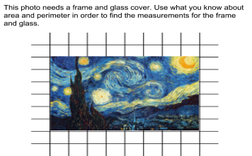 | Perimeter: 8+6+8+6=28  Area:  8+8+8+8+8+8=48  6 x 8 (6 groups of 8) = 48  6+6+6+6+6+6+6+6=48  8 x 6 (8 groups of 6) = 48
Ideas for home support

Students often get the terms area and perimeter confused. Typically, third graders do not have a lot of experience with these concepts in their everyday lives. Talk with your student about when you use the measurement concepts of area and perimeter in your everyday life to help them find relevance in and application of the mathematics they are learning.

You can help your student by using the term perimeter to describe and asking them to find the perimeter to find the outer edge of objects in their world (picture frames, legos, the barrier around the playground, the fence around the yard or ballfield, etc.).

Have your student to help you figure out the area and perimeter of an object (area rug, table, floor with tiles, etc.) Your child can estimate the measurement first. Then find the exact dimensions and the area and perimeter of the object. Discuss the process used and if their estimate was reasonable or not.

Thank you for serving as partners in your child’s success as a mathematician!

Grade 3 Math Team

